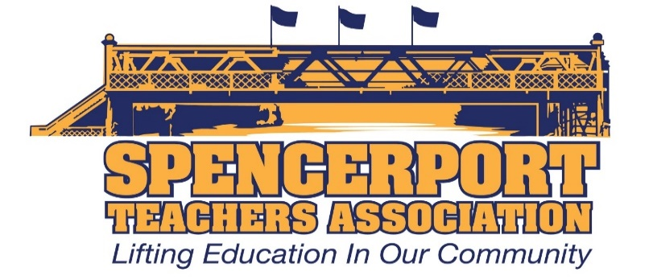

Executive Council Minutes
January 16, 2020

Attendance: Kelly Cave, Danielle Blossom, Sue Chatterton, Gretchen Breon, Jill Nundy, Teresa Trujillo, Janeen Henry, Rob Allen, SueEllen Morton, Pam Robinson, Bridget Herrmann, Steve Kelley, Amanda VanHuben, Joe DiTucci, John Kozlowski, Jacquelyn Lanpher

- Call to Order – 4:02pm.
- Secretary’s Report – The minutes from December were approved without revision or amendment. The vote to approve the minutes was unanimous. Minute reminders will now be emailed to our members with a link to our website.
- Treasurer’s Report - $35,931.83 is in our checking account, and $39,167.61 is in our savings account.
- Committee Reports
  - Grievances – None.
  - PAC – The committee has recently met several times and reviewed the issues that were raised in the STA survey. These are the items that will be brought into negotiations. The committee also reviewed NYSUT’s financial analysis of our district’s finances with Tim Miller from NYSUT.
  - BOE Report
    - 1/7 – Joe and Sue Ellen attended. The budget focus group was discussed, a board of education retreat was discussed, a new Pre-K pilot program that would be housed at Munn was reviewed, and Rob Allen gave a presentation on the implementation of the grade 6-8 Next Generation Standards.
  - Political Action Report
    - Discussions continued around the pros and cons of continuing this position. The stipend for this position is $500 per year (it was previously shared between two executive council members at $250 each). A list of duties for the position was shared. If you are interested in serving as the STA’s Political Action Coordinator, please contact John Kozlowski. If no one on EC expresses interest in this position, it will opened up to all STA members.
    - NYUSTs Legislative Forum – This year’s forum will be held on February 7, 2020 between 4 – 6 p.m. at Ridgemont Country Club. Please let John know if you are interested in attending.
  - Community Outreach – Please save the date for a STA Euchre Tournament which will be held on March 27, 2020. More details to follow.
  - Membership
    - New Teacher meetings this month include the STA t-shirts. See Rob if you need any shirts. Please encourage our members to donate to the STA Scholarship Drive. Forms are available.
    - STA apparel is in. It will be distributed soon.
    - February gift bags will be ready for our February meetings soon.

- Old Business
  - New Teacher Monthly meetings – please continue to meet with our new members.
  - Woman’s Committee – Gretchen Breon is currently a member of NYSUT’s Woman’s Committee. John shared information and a request from Jolene DiBrango, NYSUT Executive Vice-President, that the STA form a women’s committee.
  - Lamont Fundraising Opportunity – The STA has an opportunity to team up with Lamont Trophies to offer Ranger apparel to our community. The STA would earn a percentage of the total sales that we could then use to fund things like our book give-a-ways. The group discussed the pros and cons of this, and ultimately decided to do it.
  - STA Scholarship Drive – Building reps will be asking our new members to sign up and contribute to the STA Scholarship Fund. New forms were made available to building reps.

- New Business
  - NYSUT Disaster Relief Fund – John received an email from Andy Pallotta asking if any of our members would like to donate to Puerto Rico because of the recent earthquakes that have devastated the Island. John will send an email to all of our members asking them to contribute.
  - NYSUT TA Forum – January 29, 2020 from 4:30 – 6pm. Our TAs were given the information about this forum, so they can attend if they so choose.
  - STA Fundraiser at McColley’s – save the date for May 8, 2020 between 3 and 5 p.m.

The meeting was adjourned at 5:05pm
Respectfully submitted,
Jacquelyn Lanpher
STA Secretary

Future BOE Meetings:
January 21, 2020 – Bridget Herrmann
February 11, 2020 – available

