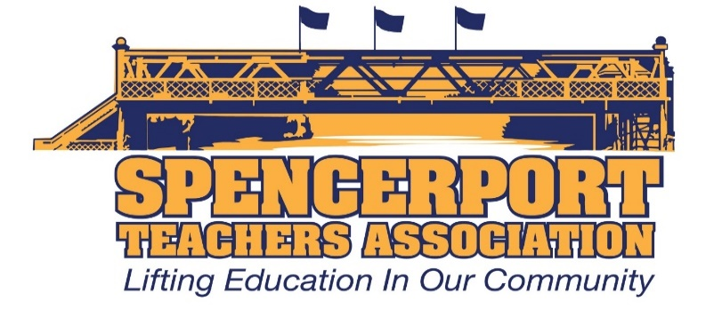

Special STA Executive Council Meeting (via email)
March 24, 2020

A motion was made by Ken Rhodes to support the Spencerport Education Foundation and donate $500 from the Spencerport Teachers Association. It was seconded by Pam Robinson, and the following Executive Council members were in favor: Ken Rhodes, Pam Robinson, Kelly Cave, Matt Fink, Scott Schwind, Becky DiNatale, Laurie Palmeteer, Bri Eason, Jacquelyn Lanpher, Steve Kelley, SueEllen Morton, Sue Chatterton, Bridget Herrmann, Cheri Hall, Amanda VanHuben, Rob Allen, Janeen Henry, Danielle Blossom, Jennifer Ott, Teresa Trujillo, Kristen Cocchiara, John Kozlowski, Joe DiTucci, Laurie Wood (and Jill Nundy – shared position).
The motion carried.

Absent: Laura Gannon

Respectfully submitted,
Jacquelyn Lanpher
March 25, 2020
11:36am

